1. Import the database and send the total count of records to Mr. Bodrog. Make sure nothing got lost.

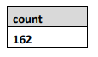

1. Select the size of the longest magic wand. Rename the new column appropriately.

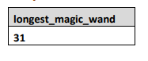

1. For wizards in each deposit group show the longest magic wand. Sort result by longest magic wand for each deposit group in increasing order, then by deposit_group alphabetically. Rename the new column appropriately.

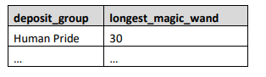

1. Select all deposit groups and its total deposit sum. Sort result by total_sum in increasing order.

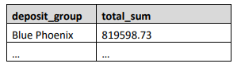

1. Select all deposit groups and its total deposit sum but only for the wizards who has their magic wand crafted by Ollivander family. Sort result by deposit_group alphabetically.

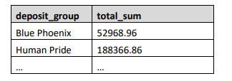

1. Select all deposit groups and its total deposit sum but only for the wizards who has their magic wand crafted by Ollivander family. After this, filter total deposit sums lower than 150000. Order by total deposit sum in descending order.

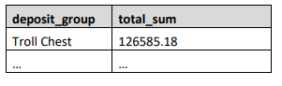

1. Create a query that selects: • Deposit group • Magic wand creator • Minimum deposit charge for each group Group by deposit_group and magic_wand_creator. Select the data in ascending order by magic_wand_creator and deposit_group.

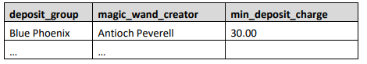

1. Write down a query that creates 7 different groups based on their age. Age groups should be as follows: • [0-10] • [11-20] • [21-30] • [31-40] • [41-50] • [51-60] • [61+] The query should return: • Age groups • Count of wizards in it Sort result by increasing size of age groups.

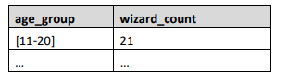

9. Mr. Bodrog is highly interested in profitability. He wants to know the average interest of all deposits groups split by whether the deposit has expired or not. But that’s not all. He wants you to select deposits with start date after 01/01/1985. Order the data descending by Deposit Group and ascending by Expiration Flag.

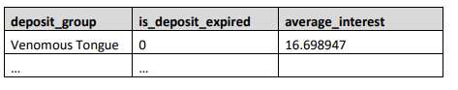

10. That’s it! You no longer work for Mr. Bodrog. You have decided to find a proper job as an analyst in SoftUni. It’s not a surprise that you will use the soft_uni database. Select the minimum salary from the employees for departments with ID (2,5,7) but only for those who are hired after 01/01/2000. Sort result by department_id in ascending order. Your query should return: • department_id

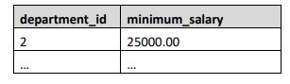

11. Select all high paid employees who earn more than 30000 into a new table. Then delete all high paid employees who have manager_id = 42 from the new table; Then increase the salaries of all high paid employees with department_id =1 with 5000 in the new table. Finally, select the average salaries in each department from the new table. Sort result by department_id in increasing order.

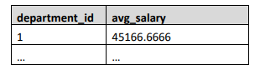

12. Find the max salary for each department. Filter those which have max salaries not in the range 30000 and 70000. Sort result by department_id in increasing order.

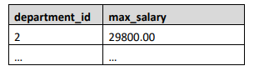

13. Count Salaries Count the salaries of all employees who don’t have a manager.

14. Create a query which shows the total sum of salaries for each department. Order by department_id. Your query should return: • department_id

